Group symbol: 3
Team: 1

Project title: Resource Allocation App

Team members (filled by PM, Team Leader):
No | Name | Surname | Student ID | Role
1 | Carmelo Aidan | Romero | 293936 | PM, Team Leader
2 | Álvaro | Puebla | 293867 | Team member
3 | David | Sosa | 293885 | Team member
4 | Diego | Ceballos | 293943 | Team member
5 | Diego | García | 293939 | Team member
6 | Óscar | López | 293871 | Team member

- Design (S3)
  - Logical Software Architecture
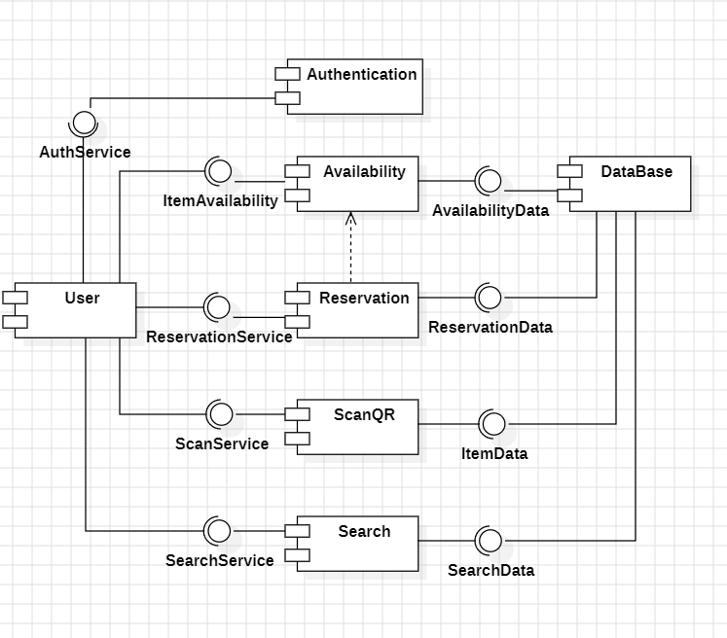
The logical architecture aspect of the system should be present as a Component Diagram expressed in UML 2.5.

  - Business Logic Model
    - Behavioural Model
In this section present:
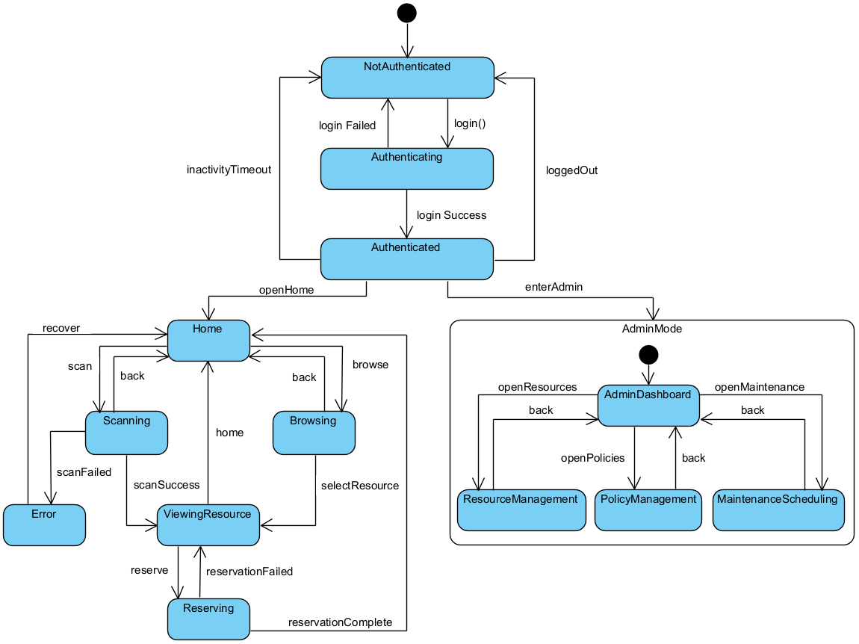
  - state diagram for whole the system and

  - behaviour of 2 crucial use cases using the UML 2.5 diagrams, namely sequence diagram, and activity diagram.
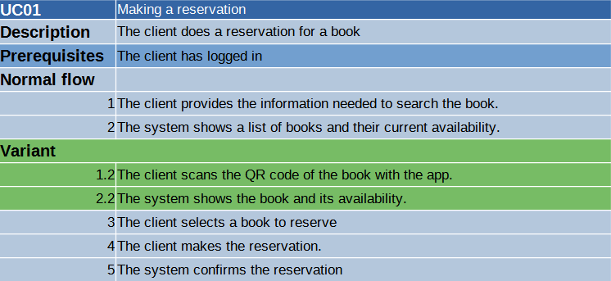
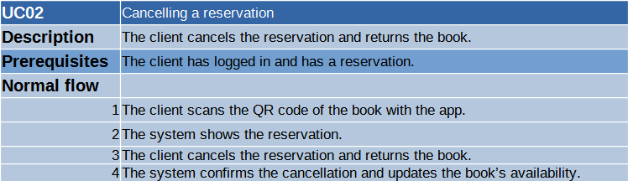

    - Structural Model
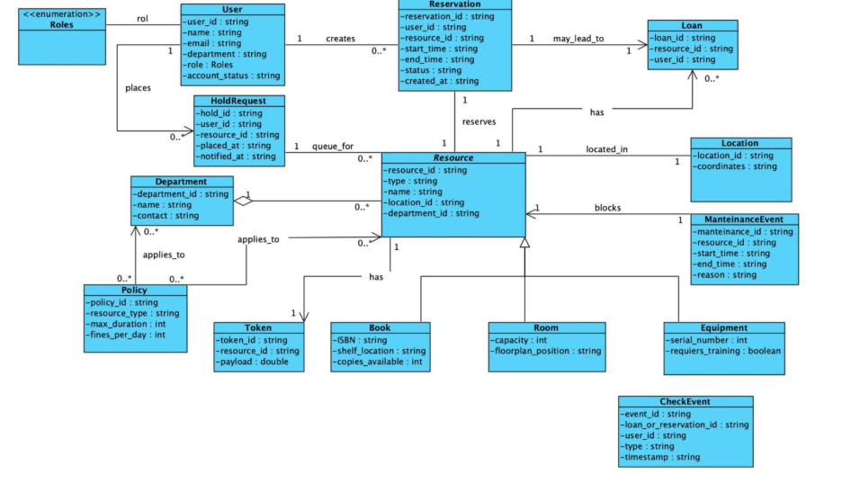
Prepare the model as class diagram expressed in UML 2.5. Use natural language to describe the semantics of models’ elements. Besides, use the object diagram to present an instance of the model at the time of system execution.

  - Database Model
    - Conceptual Model
The model contains the definition of entities and relationships among them in terms of the database (persistence). You should present it as a diagram and description of key elements in natural language.
User Attributes: • user_id (PK) • name • email • role (student / professor / admin)
Student Attributes: • student_id (PK, FK → User.user_id) • enrollment_number • degree_program
Professor Attributes: • professor_id (PK, FK → User.user_id) • department
Course Attributes: • course_id (PK) • name • professor_id (FK → Professor.professor_id)
Relationships: A professor teaches many courses; a course is taught by one professor.
Classroom Attributes: • classroom_id (PK) • name • capacity
ClassroomReservation Attributes: • reservation_id (PK) • classroom_id (FK → Classroom.classroom_id) • professor_id (FK → Professor.professor_id) • course_id (FK → Course.course_id) • date • start_time • end_time
Relationships: A classroom can have many reservations; a professor can make many reservations; each reservation belongs to one classroom, one professor, and one course.
Book Attributes: • book_id (PK) • title • author • year • available (boolean)
BookLoan Attributes: • loan_id (PK) • book_id (FK → Book.book_id) • student_id (FK → Student.student_id) • loan_date • return_date
Relationships: A student can borrow many books; a book can appear in many loans; each loan links one book and one student.
StudentCourse (optional, for enrollments) Attributes: • student_id (FK → Student.student_id) • course_id (FK → Course.course_id)
Relationship: Many-to-Many between students and courses.

    - Physical Model
The model presented as a diagram of the database that constitutes the implementation of the conceptual model in the selected database management system.
It is required to include an elaboration on the transformation of the conceptual model to the physical model. Description of transformation should include how elements like, e.g. inheritance and associations or other sophisticated modelling concepts have been handled.

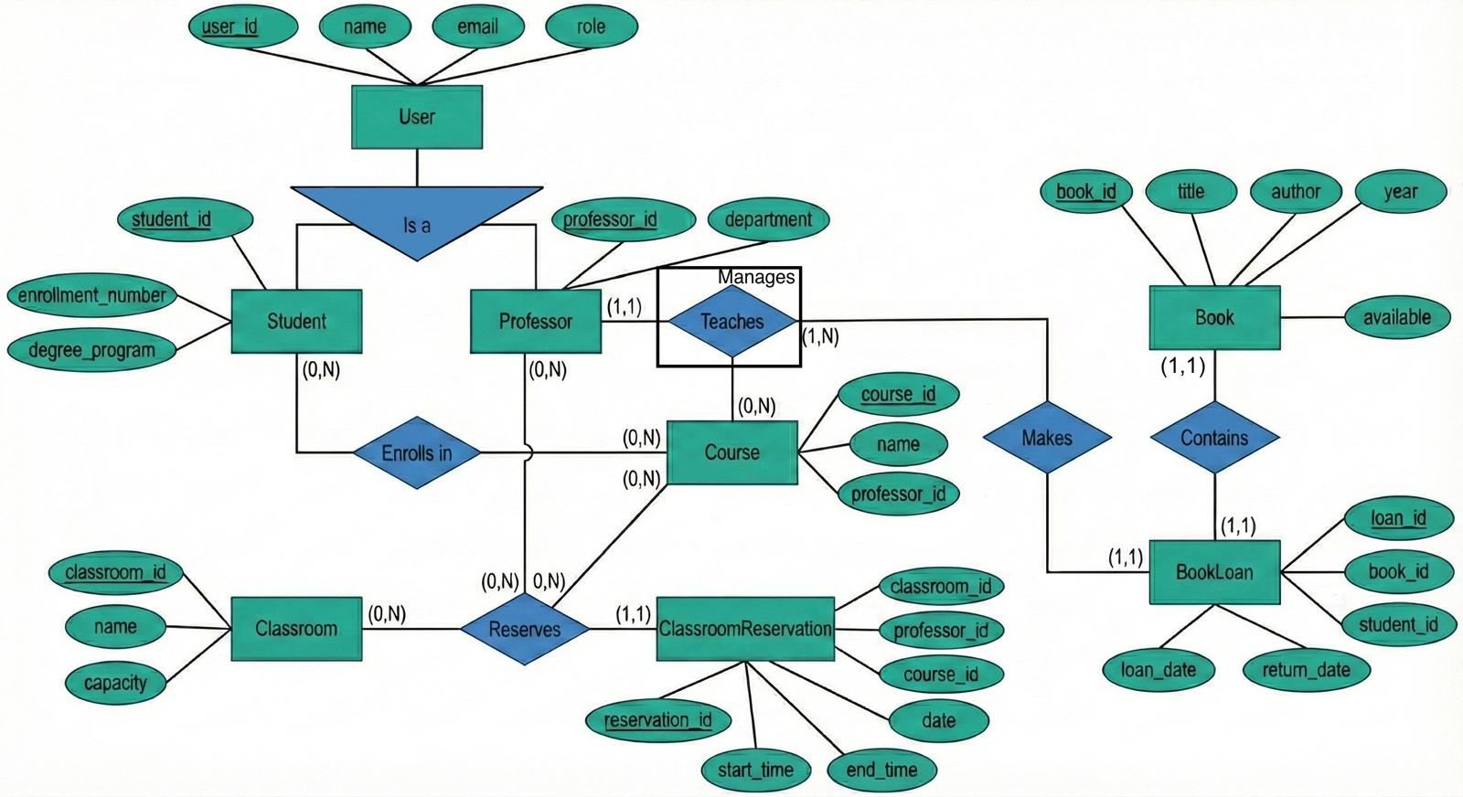

  - User Interface Design
In this section, you should present the distribution of user interface components with events and their assignments to the behaviour specifications, which these elements initiate or take part.
These are the different pages we designed for this project, but we do not discard the fact that we may need to make new ones as the project advances and evolves.
